[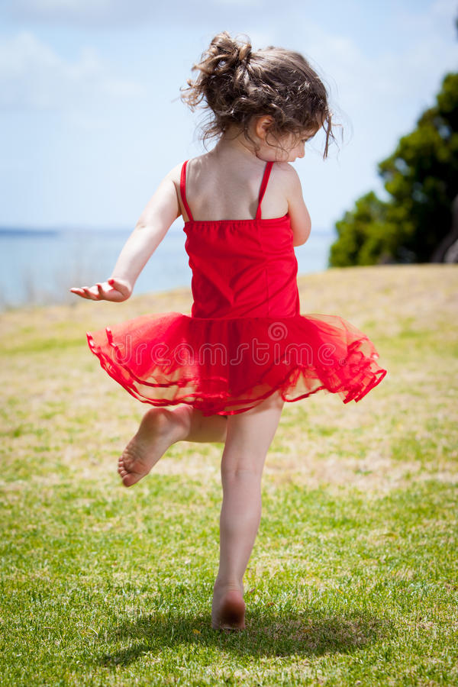](https://www.google.be/url?sa=i&rct=j&q=&esrc=s&source=images&cd=&cad=rja&uact=8&ved=2ahUKEwjvmsybpNPbAhXKFiwKHcPcAxMQjRx6BAgBEAU&url=https://nl.dreamstime.com/royalty-vrije-stock-foto-s-dansend-kind-image30837258&psig=AOvVaw1fP4uWJSpdXaVSzXLoARJc&ust=1529070063640929)

**spontaan dansen**

**Ik kan**